Falling and Forces
Friction is the force that resists the movement of an object as it moves over the surface of a material it is contact with.
When an object falls there is a friction between the falling object and the air it is falling through. This friction is known as ____________ ____________.
The greater the surface area an object has the greater the __________ _______________.

Falling Ball

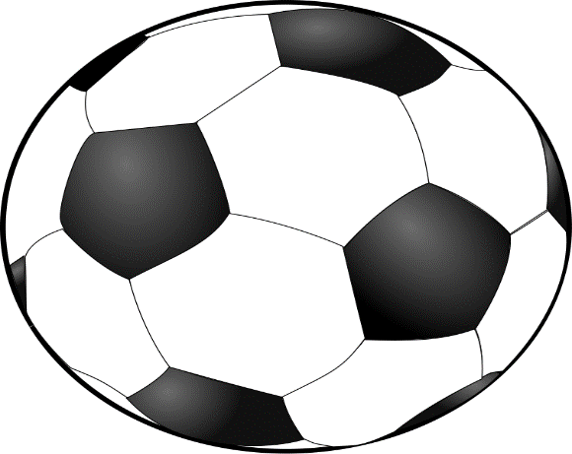

Terminal velocity is the highest speed an object reaches as it falls through air. It is reached once the air resistance equals the pull of gravity. The objects keeps falling, but it stops accelerating and falls at a constant speed.

Stage of fall | What is happening
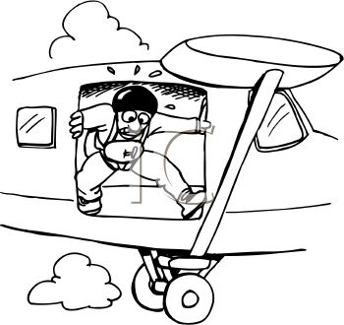 |  | Before jumping. The pulling force of gravity is balanced by the upward force of the plane the pilot is standing in.
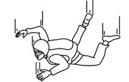 |  | Speeding up. Initially the skydiver speeds up because the ___________ __________ is low.
 |  | Terminal Velocity. As speed increases so does _______ __________. _____ ___________ and gravity are b_________________. Stops accelerating. The speed of falling remains c________________.
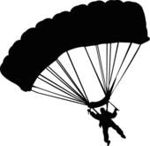 |  | Slowing down. Once the parachute is opened , the force of ______ _________ is greater and the pilot ____________ down.

